OPENEDED LAB

LAB TASK :
A ) Write a Java program where Employee has a salary, Manager adds a bonus, and Director adds stock options. Override calculateSalary() in each class to return total salary. [Take user input for all values and print total salaries]. Write a Java program where Employee has a salary, Manager adds a bonus, and Director adds stock options. Override calculateSalary() in each class to return total salary. [Take user input for all values and print total salaries].
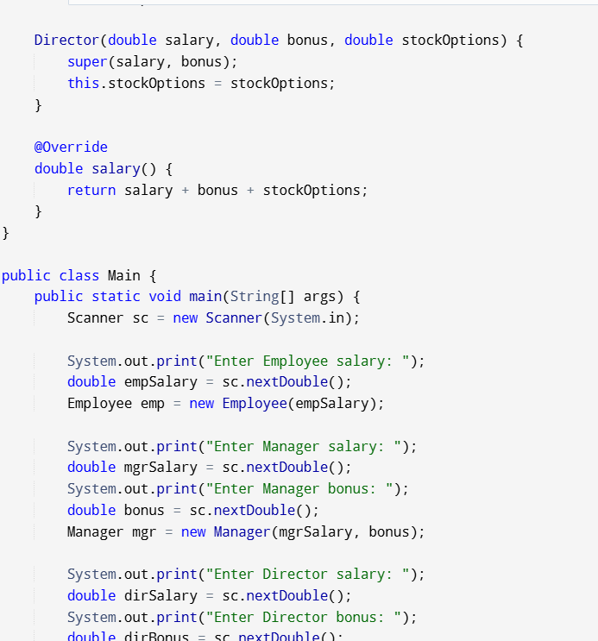
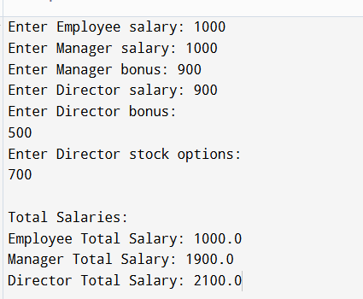l

B ) Write a Java program to calculate areas of multiple circles using threads (one to compute, one to print), apply sleep(), wait(), stop(), and optimize the line of code given [Take ‘radius (r)’ as user input] totalArea = (22/7)*r*r + (22/7)*r*r;
CODE :
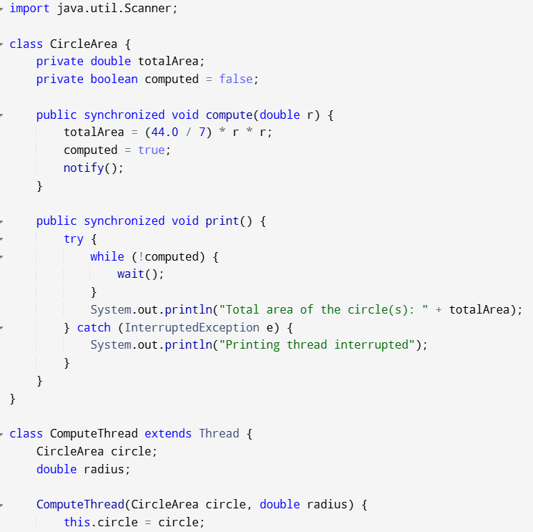
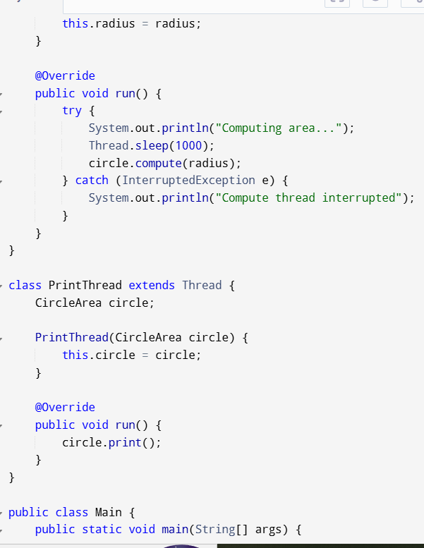
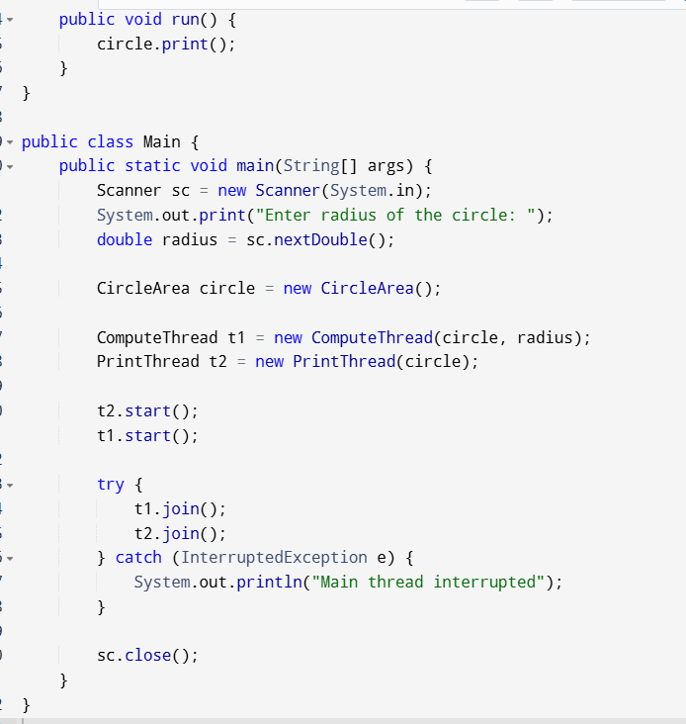
OUTPUT :
